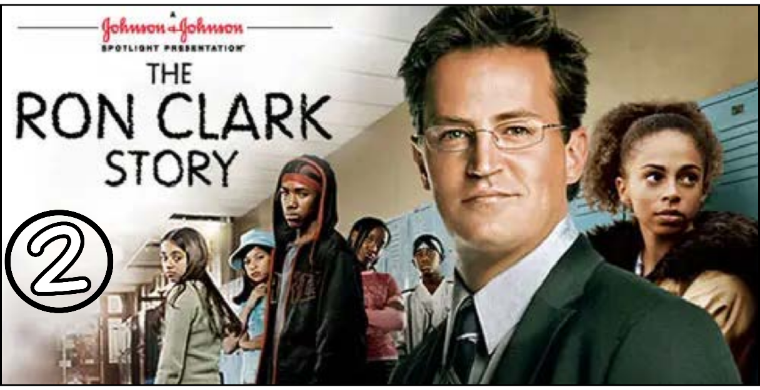
“The Ron Clark Story” (Scene 02)

Scene pparation

- Scene summary:

“ In this scene , Mr. Clark was a well-respected teacher in North Carolina but he moved to New York to discover new teaching opportunities. However , Mr. Clark does not immediately and easily find work . Finally , he found a turbulent primary class teaching position in Inner Harlem Elementary school . Mr. Clark does not start immediately , he meets the students' parents first .”

- Scene Discussion & Analysis:

- Q01: What does Mr. Clark do for a living?
Mr. Clark is a teacher but he is searching for new position now .
- Q02: Did he find a job quickly in Harlem?
No , he didn’t
- Q03: What is your impression on this city “Harlem”? assault / violent
“ Harlem looks as a poor dirty district . The inhabitants are mostly black and from other non American nationalities . People there look poor and miserable . Harlem gives the impression of unsafety .
- Q04: In your opinion ... Mr. Clark was a highly respected teacher back in North Carolina. Why did he want to move to New York where nobody knows him?
- Mr. Clark decided to move to New York to achieve his dream and discover new opportunities. He also wants to unlock new challenges of teaching students of New York and helping them in their studies.
Q05: Mr. Clark eventually found a job at Inner Harlem Elementary School. What is your impression on the school and the class he is going to teach?
The school seems to have so many bad students and the class Mr. Clark is going to teach seems to have students struggling with learning and discipline
Q06: Did Mr. Clark start teaching immediately?
No , he didn’t S + V + o
Q07: If not, what did he do before he started teaching?
He met the students’ parents .

- Acquired Vocabulary (OPTIONAL):

- Detention:
- Example in a sentence:
“ She was given detention for cheating in the exam “
- An assault charge:
- Example in a sentence:
“ The judge considered an assault charge to decide on them “
- Sincere
- Example in a sentence:
“ They say on trouble , sincere is the only thing one needed “
- squirrely
- Example in a sentence:
“ He gets a bit squirrely before giving a big presentation “

- Irregular Verbs:

Infinitive | Past simple | Past participle
To teach | Taught | Taught
To meet | Met | Met
To read | Read | Read

Additional Exercise (Optional)

Task: Transcribe sentences from the scene.

- [00:19] Transcribe Sentence 01
- Why you want school listing for ? “
- [00:49] Transcribe Sentence 02
- I apologize , we just don’t have a position available “
- [02:33] Transcribe Sentence 03 two strikes going on three
- Hello ! I’m Ron Clark , I wanted to let you know I taught 5 ^{th} grade four years in North Carolina . You need a teacher , I need a job .So , Let’s help each other out .
- [03:17] Transcribe Sentence 04
- This class tested at the bottom of The entire New York city school district “.

- ... .... ..... ..... ..... ..... ... .... ..... ..... ..... ..... ... .... ..... ..... ..... ..... ... .... ..... ..... ..... ..... ... .... .... ...

What I struggled WITH? (Optional)

.... .... .... .... .... .... ..... .... .... .... .... .... ..... .... .... .... .... .... ..... .... .... .... .... .... ..... .... .... .... .... .... ..... .... .... .... .... .... ..... .... .... .... .... .... ..... .... .... .... .... .... ..... .... .... .... .... .... ..... .... .... .... .... .... ..... .... .... .... .... .... ..... .... .... .... .... .... ..... .... .... .... .... .... ..... .... .... .... .... .... ..... .... .... .... .... .... ..... .... .... .... .... .... ..... .... .... .... .... .... ..... .... .... .... .... .... ..... .... .... .... .... .... ..... .... .... .... .... .... ..... .... .... .... .... .... ..... .... .... .... .... .... ..... .... .... .... .... .... ..... .... .... .... .... .... ..... .... .... .... .... .... ..... .... .... .... .... .... ..... .... .... .... .... .... ..... .... .... .... .... .... ..... .... .... .... .... .... ..... .... .... .... .... .... ..... .... .... .... .... .... ..... .... .... .... .... .... ..... .... .... .... .... .... ..... .... .... .... .... .... ..... .... .... .... .... .... ..... ........ .... ..... .... .... .... .... .... ..... .... .... .... .... .... ..... .... .... .... .... .... ..... .... .... .... .... .... ..... .... .... .... .... .... ..... .... .... .... .... .... ..... .... .... .... .... .... ..... .... .... .... .... .... ..... .... .... .... .... .... ..... .... .... .... .... .... ..... .... .... .... .... .... ..... .... .... .... .... .... .....

